show databases;
create database test;
use test;

create table person(
driver_id varchar(10) primary key,
name varchar(20),
adress varchar(30));
desc person;

create table car(
reg_num varchar(10) primary key,
model varchar(10),
year int);
desc car;

create table accident(
report_num int primary key,
accident_date date,
location varchar(20) );
desc accident;

create table owns(driver_id varchar(10),reg_num varchar(10),
primary key(driver_id, reg_num),
foreign key(driver_id) references person(driver_id),
foreign key(reg_num) references car(reg_num));
desc owns;

create table participated(driver_id varchar(10), reg_num varchar(10),
report_num int, damage_amount int,
primary key(driver_id, reg_num, report_num),
foreign key(driver_id) references person(driver_id),
foreign key(reg_num) references car(reg_num),
foreign key(report_num) references accident(report_num));
desc participated;

insert into person values("A01","richard","srinivas nagar"),
("A02","pradeep","rajaji nagar"),
("A03","smith","ashok nagar"),
("A04","venu","nk colony"),
("A05","john","hanuman nagar");

insert into car values("KA052250","indica",1990),
("KA052251","toyota",1957),
("KA052252","honda",1998),
("KA052253","audi",2008),
("KA052254","lambo",2005);

insert into owns values("A01","KA052250"),
("A02","KA052251"),
("A03","KA052252"),
("A04","KA052253"),
("A05","KA052254");

INSERT INTO accident VALUES(11, '2003-01-01', 'Mysore Road'),
(12, '2004-02-02', 'South end Circle'),
(13, '2003-01-21', 'Bull temple Road'),
(14, '2008-02-17', 'Mysore Road'),
(15, '2005-03-04', 'Kanakpura Road');

INSERT INTO participated VALUES('A01', 'KA052250', 11, 10000),
('A02', 'KA052251', 12, 20000),
('A03', 'KA052252', 13, 25000),
('A04', 'KA052253', 14, 30000),
('A05', 'KA052254', 15, 50000);

select * from person;
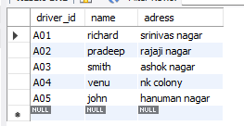
select * from car;
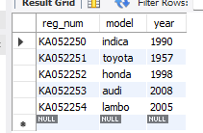
select * from owns;
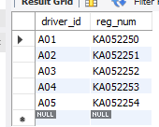
select*from accident;
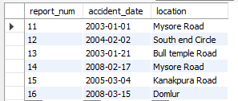

select*from participated;
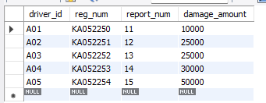

update participated set damage_amount=25000 where report_num=12;
insert into accident(report_num, accident_date, location)
values (16,'2008-03-15','Domlur');

select * from car order by year asc;
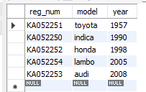

select count(*) CNT from car c,participated p where c.reg_num=p.reg_num and model="audi";


select count( driver_id) CNT from participated a,accident b where a.report_num=b.report_num and year(b.accident_date)=2003;


select * from participated order by damage_amount desc;
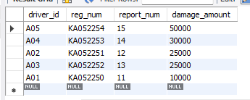
-- week 02
select accident_date, location from accident;
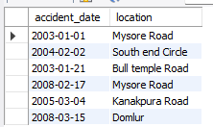

select p.driver_id, p.name, c.model from person p, car c,owns o
where p.driver_id = o.driver_id and o.reg_num = c.reg_num;
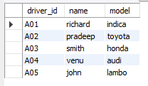

select a.report_num, a.accident_date, a.location, m.driver_id, p.damage_amount
from accident a,participated p, person m
where a.report_num = p.report_num and p.driver_id = m.driver_id;
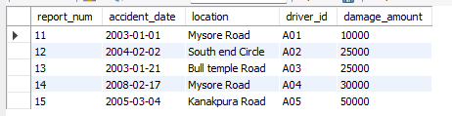

select report_num, SUM(damage_amount) AS total_damage
from participated
group by report_num;
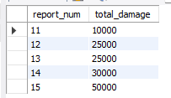

select driver_id, count(distinct report_num) as accident_count
from participated
group by driver_id
having count(distinct report_num) > 1;


select c.reg_num, c.model
from car c ,participated p
where c.reg_num = p.reg_num and p.reg_num IS NULL;


select * from accident order by accident_date desc limit 1;


select driver_id, avg(damage_amount) AS avg_damage from participated group by driver_id;
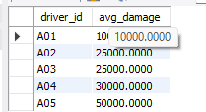

select driver_id, damage_amount from participated
order by damage_amount desc limit 1;
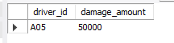

select distinct driver_id,damage_amount from participated where damage_amount >= 25000;
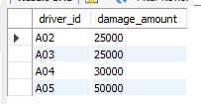

select c.model, p.damage_amount
from car c,participated p
where c.reg_num = p.reg_num and damage_amount>20000;
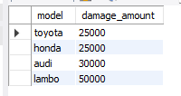

create view acci_summary as
select
a.report_num, a.accident_date, a.location,
count(p.driver_id) as participant_count,
sum(p.damage_amount) as total_damage
from accident a,participated p
where a.report_num = p.report_num
group by a.report_num;

select * from acci_summary;
